**Task-2**

Combine Matplotlib with pandas to create advanced data visualizations with labeled data points and statistical overlays.

1. **Task** **Description:**

* To create advanced data visualizations by combining **Matplotlib** and **Pandas** and take advantage of both libraries' powerful features. Here, I'll show how to create a scatter plot with labeled data points and add a statistical overlay, like a regression line, along with summary statistics like the mean and standard deviation.

1. **Task Output Screenshot:**

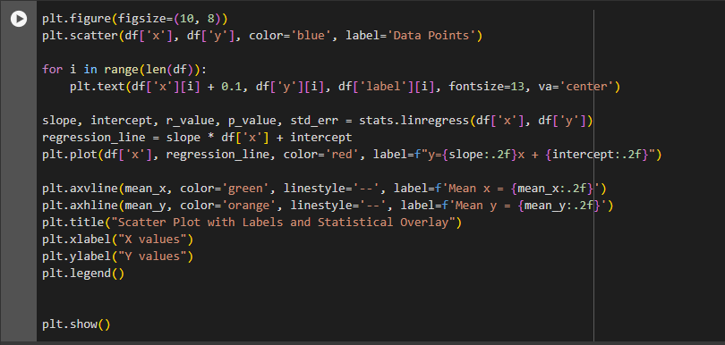

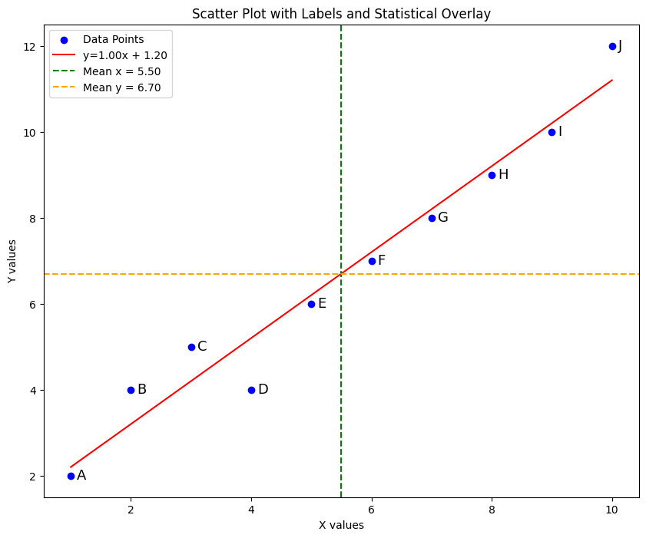

1. **Algorithm Used In Task**

* Load the data using Pandas.
* Create a scatter plot using Matplotlib.
* Label each data point with corresponding text from the DataFrame.
* Add a regression line as a statistical overlay.
* Overlay statistical summaries (mean, standard deviation, etc.).